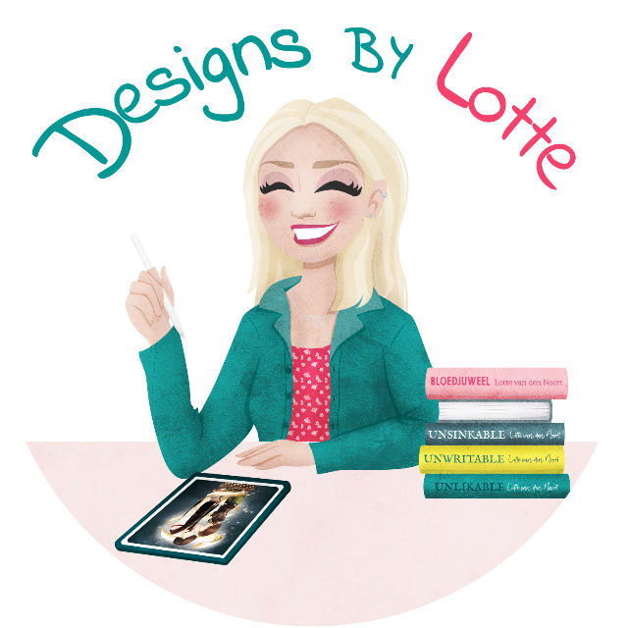

BOOK COVER DESIGN INFORMATION
Thank you for your interest in a custom-made book cover! The questions below help me get a clear picture of your preferences. While I do my utmost best to meet your vision, I want to emphasize that designing a book cover is a creative process in which my own style also plays a role. I hope you take this into account. For more information on revision rounds and procedures, please refer to my terms and conditions on my website.

Note: I am NOT an illustrator. Anything you want on your book cover must be available on stock image websites. If you have extremely specific requests that cannot realistically be photographed, you will need to consult an illustrator. Based on your briefing, I can determine whether I can meet your expectations. Check my portfolio on my website to see if my style aligns with your needs!

For the publisher (fill in if applicable)
- Book format (including bleed and technical specifications):
Enter the format here.

- Printing options:
  - Hardcover / Paperback / E-book (multiple options possible, cross out what does not apply)
  - Any extras (such as sprayed edges, foil printing, embossing, dust jacket, etc.) Comes with an additional charge! See the ‘add-ons’ section on the pricing page.
Enter any extras here.

- ISBN:
Enter the ISBN here.

- Will the interior layout also be done by me:
Yes, no, or not applicable.

- Choose your package: bronze / gold / platinum (cross out what does not apply, see pricing page for descriptions)
Enter the desired package here.

Content-related questions about the book cover
- Title of the book:
Enter the title here.

- Is this book part of a series: yes / no (cross out what does not apply)
  - If so, do you already have a vision for other covers or a direction you want to follow?
Provide as much concise information as possible.

- Subtitle of the book (if applicable):
Example: The Heirs, Part 1.

- Author's name (as it should appear on the cover):
Enter your author name or pseudonym here.

- Tagline or slogan (optional):
For example: Love and hate are closely intertwined.

- Short summary of the book:
  - Describe the story in a few sentences, including the main themes and atmosphere.
Provide as much concise information as possible.

- Elements you would like to see on the cover:
  - Provide as much detail as possible so that I can understand your vision. Don’t just say “a girl” or “a tree,” but give a detailed description: for a girl, for example, specify hair color, age, clothing style, and expression. For a tree, specify the type of tree, such as an oak or pine, and any specific characteristics that make it important to the story. This helps me translate your ideas more accurately into an image.
Enter the details here.

- Elements you absolutely do not want on the cover:
  - Things you would rather avoid, such as certain colors, symbols, or styles.
Enter here.

- Prefered color palette:
Paste your favorite colors here, or describe them.

- Reference covers:
  - Examples of covers you like that match the story (please explain why).
Paste your favorite covers here.

- Covers you do not like:
  - Examples of covers you would rather avoid and the reasons why.
Paste your least favorite covers here.

Important to know: As a designer, I aim to translate your ideas and vision into an attractive, professional cover. However, since the creative process involves interpretation and artistic freedom, I ask that you remain open to my creative input. Micromanagement can be limiting, as it disrupts the creative flow and makes it harder to achieve a unique, professional final result. Trusting the process and my experience as a designer usually leads to a much better outcome.

For more information on revision rounds and the process,
please refer to my terms and conditions on my website (www.designsbylotte.nl)

If you have any questions, feel free to get in touch!

